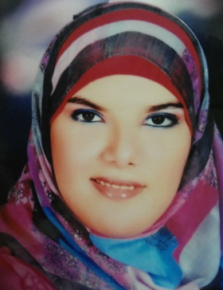

Radwa Adel Mahmoud Ibrahim Azzam
SoftwareDeveloper
Oracle(SQL,PL/SQL,Forms)

Cell phone:+201288966644
Email: radwaazzam1@gmail.com



•Objective

Full / Part-Time position within highly organized corporation,toutilize my past educational & practical experiences and knowledge in areas of database design, programming using Oracle PL/SQL,Forms, my sql database.

•Personal Information

o Address:portsaid-Alzohor-EL 5000 St.-House No.39-Flat No.5.
oDate of birth:21/4/1992.
oNationality:Egyptian.
oGender: female.
oMarital Status:single.

•Education

oportsaid university,BachelorofEngineering(B.SC)Jun 2014.
oDepartment: Electronics(computersandsystems).
oGrade: Good.
oGrade of Graduation Project:very good.
oGraduation Project Name: Life Drop.

•Certifications

oITShare Company Certificate (oracle database10g)
oAdobe Photoshop C6
oAdobe Dreamweaver C5
oICDL Certificate

•Courses

-icdl(2012)

1-International Computer Driving Licenses for Microsoft Office 2010 application.
- Database(2013)

1- Basics of database designmethodology (data modeling, process modeling and ERD &DFD)

2- Oracle Developer10g(Sql –PL/Sql-Forms).

-Photoshop(2013)

- Dreamweaver(2013)

•Experience

Duration:from10/2013 until 7/2014.

Location:

-portsaid university (graduation project).

Duties:

- Performing system analysis and Database design for departments that are not covered By Oracle software and develop solutions to it.

•personal &Generalskills

1- Strong training skills.

2-Good communication skills In Arabic and English..

3- Confident, trustworthy and good team player.

4- Ability to work under stress to fulfill predefined work plan.

•languagesskills

-Reading ,Listening English : V.Good. –Speaking ,Writing English : V. Good.

